**D1 – Compare different specialist computer animation software packages**

**Introduction**

In this report, I will compare the different specialist computer animation software packages available.

**Toon Boom**

Toon Boom is a Canadian software company that specialises in computer animations. This was founded in 1994. Toon Boom specialises in 2D animation. Big animation companies use this software such as Family Guy, The Inner World, The Princess and the Frog and many more.

**Comparison Toon Boom vs. Maya**

The difference between the Toon Boom and Maya is Toon Boom focuses on 2D animation, whereas Maya focuses on 3D animation. The cost between the two is varied too. Maya is more expensive than Toon Boom because of the fact that it is 3D animation. 3D animation has tools that 2D animation does not use.

**Blender**

[Blender.svg](http://en.wikipedia.org/wiki/File:Blender.svg)Blender is an animation software, released in 1995, that allows animation in 3D to be made. It is professional that uses many different varied films. An example of what Blender is used to create is visual effects, 3D printed models, interactive 3D applications and video games.

**Comparison Blender vs. Maya**

Both, Maya and Blender, are the same software that do the same thing. They both use 3D animation for various subjects. The difference between the two is that Maya is expensive and Blender can be downloaded of the internet. The editing mode of both is the same, but blender is the better version for starters. It is simpler for beginners to learn animation, but it is complex to do complex animation.

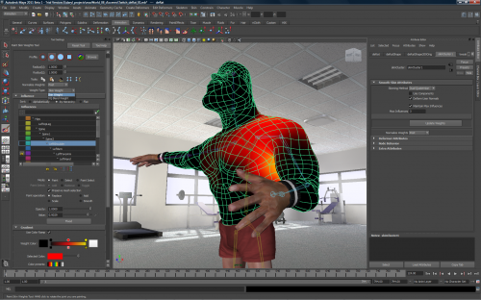

**Maya**

Maya is an animation software where 3D animated cars to be made by professional animators. Maya is a similar software animation to Blender.

As you can see, the example is shown on the left. This shows how animation is created using Maya software.

[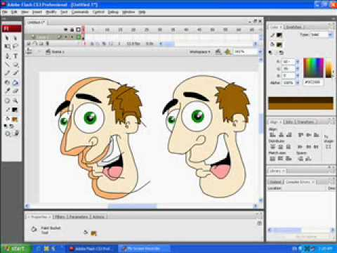](http://www.google.co.uk/url?sa=i&rct=j&q=&esrc=s&source=images&cd=&cad=rja&uact=8&ved=0CAcQjRw&url=http%3A%2F%2Fwww.youtube.com%2Fwatch%3Fv%3DIKg74SXwBLY&ei=KCtfVd7wIs7T7AbVnoC4CQ&bvm=bv.93990622,d.ZGU&psig=AFQjCNH9TAsY0Rs8RY0wcN96oiPo7FehBw&ust=1432386728046843)**Flash**

Flash animation is used by Adobe Flash to create 2D animation. An example is shown of how Adobe Flash is used. You can move them both about to do anything you need it do. Some Adobe Flash can be used on websites to attract customers.

**Pivot StickFigure Animator**

[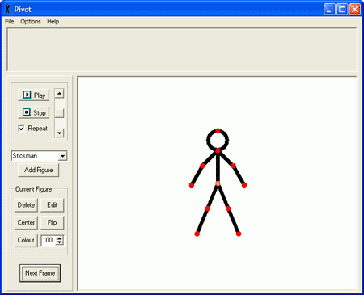](http://www.google.co.uk/url?sa=i&rct=j&q=&esrc=s&source=images&cd=&cad=rja&uact=8&ved=0CAcQjRw&url=http%3A%2F%2Fwww.pendriveapps.com%2Fpivot-stickfigure-animator%2F&ei=DSlfVYfeD8Ga7gblp4HYDQ&bvm=bv.93990622,d.ZGU&psig=AFQjCNGSsuBpraeB2pMvAh6VD79mPWqcmw&ust=1432386182874350)Pivot StickFigure is a simple ‘stick’ animation software that is aimed at for users who wants to start to learn animation. Pivot uses stickmen to create its animated software. The picture shows how Pivot is started. You can make the user walk and do whatever you want with it. You can even add new figures by creating your own too.

**Comparison Pivot vs. Flash**

The difference between the two is that Pivot is mainly aimed at using stickmen, whereas Flash uses cartoon to do this. They are both used differently too. However, they both are used to teach students from GCSE to A level. Pivot is cheap than Adobe Flash. The main difference is that Flash is a professional software, however, Pivot is mainly used for hobby.

**Reference**

<https://www.toonboom.com/resources/tips-and-tricks/2d-3d-integration>